­

Lab VI – From SQL Injection Attacks to Shell

CPS 499-02/592-02

Software/Language Based Security

Fall 2020

Dr. Phu Phung

Evan Krimpenfort

# Part I: Exploiting the SQL Injection Vulnerabilities to obtain data from the database

## Task I: Discover the SQL vulnerabilities

### Display UD email ID on the website

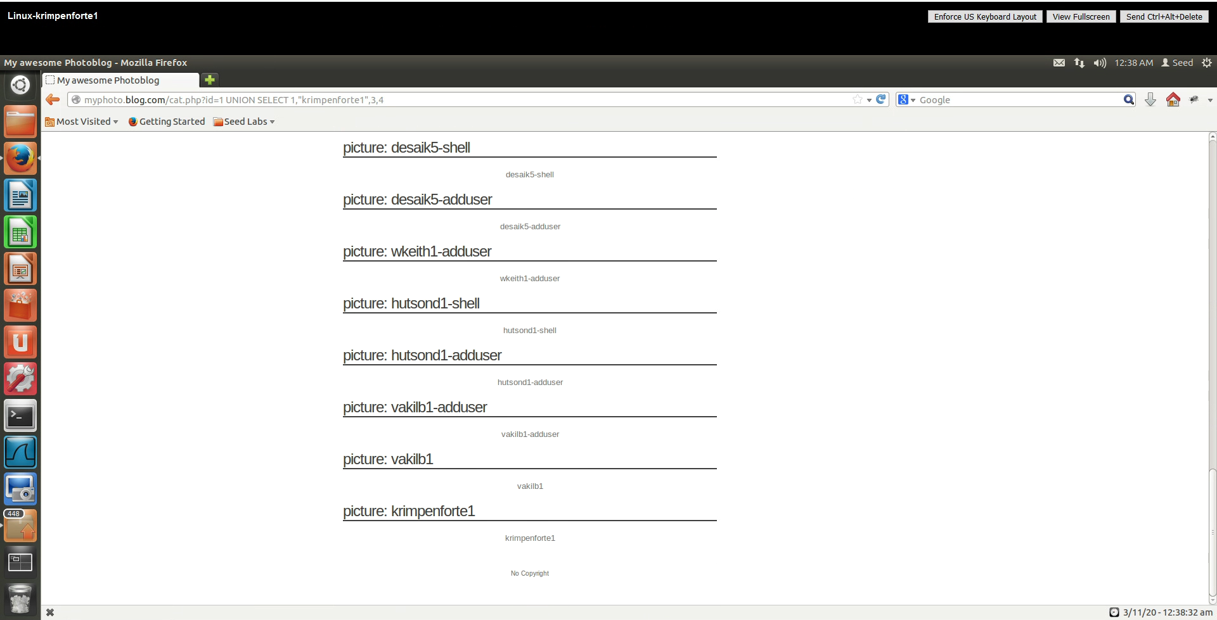



**Figure 1: putting in my email ID for column 2.**

### Find current_user()

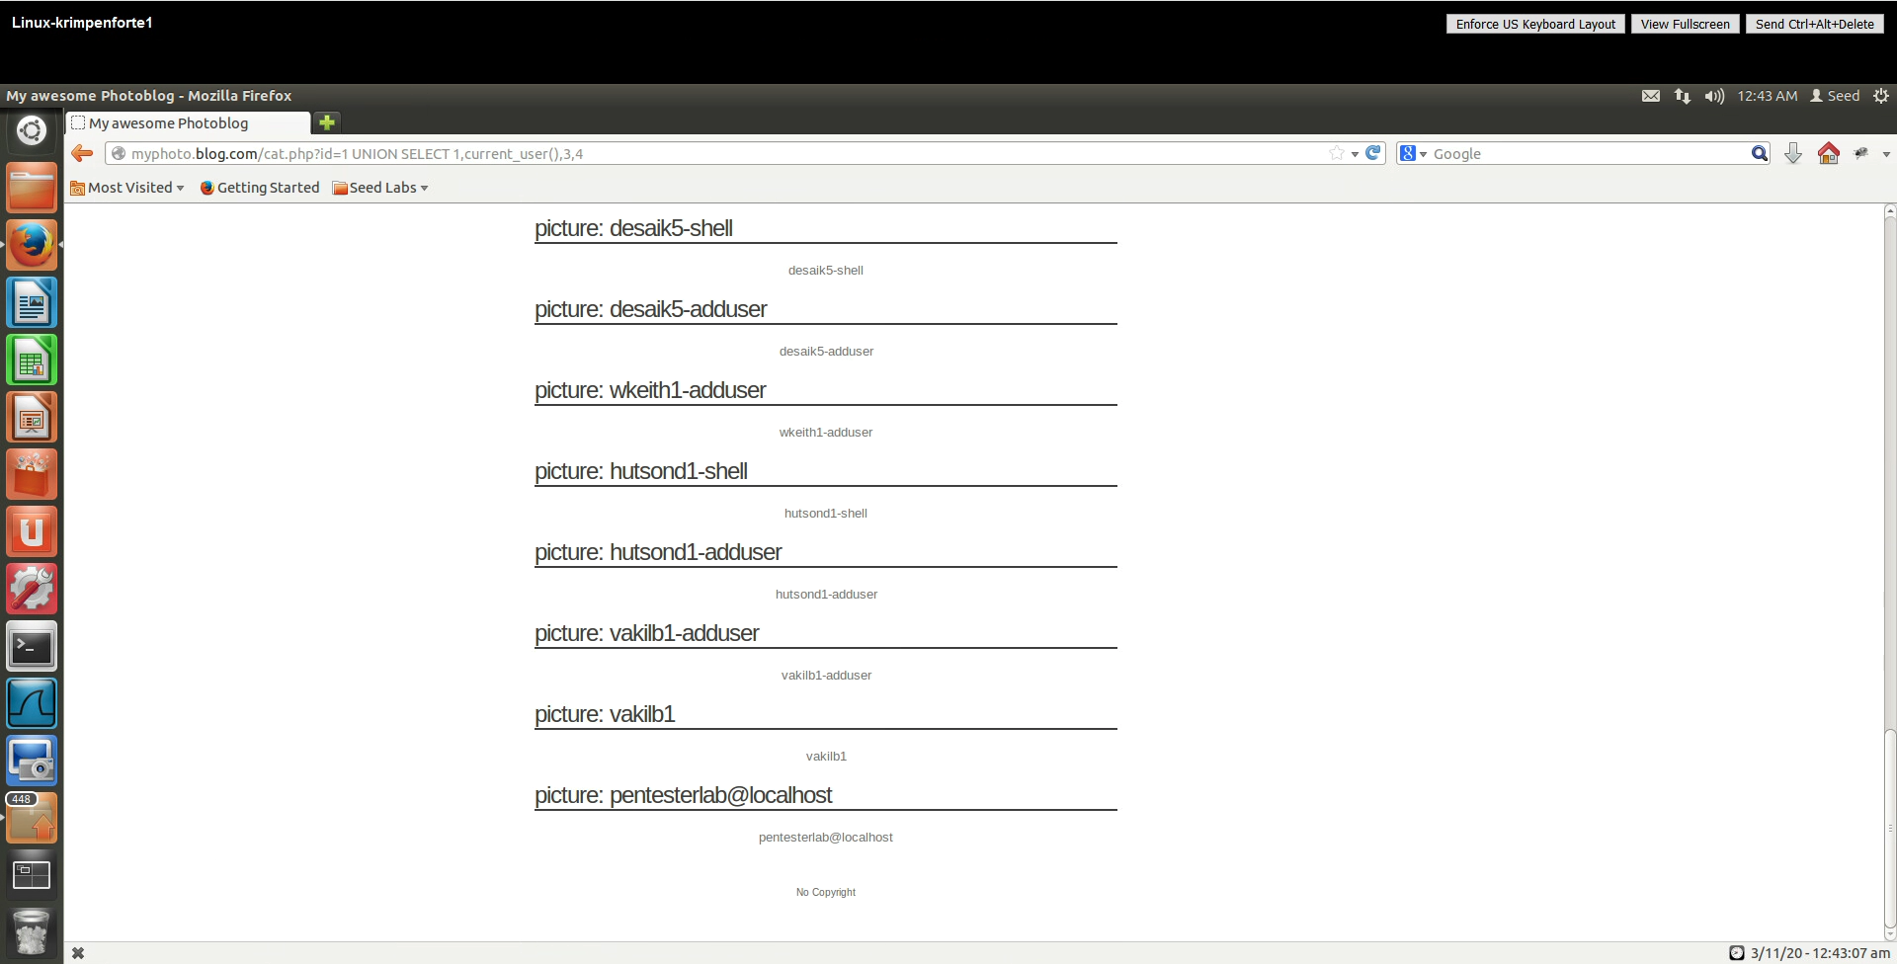



**Figure 2: putting in the function “current_user()”**

### Find database()

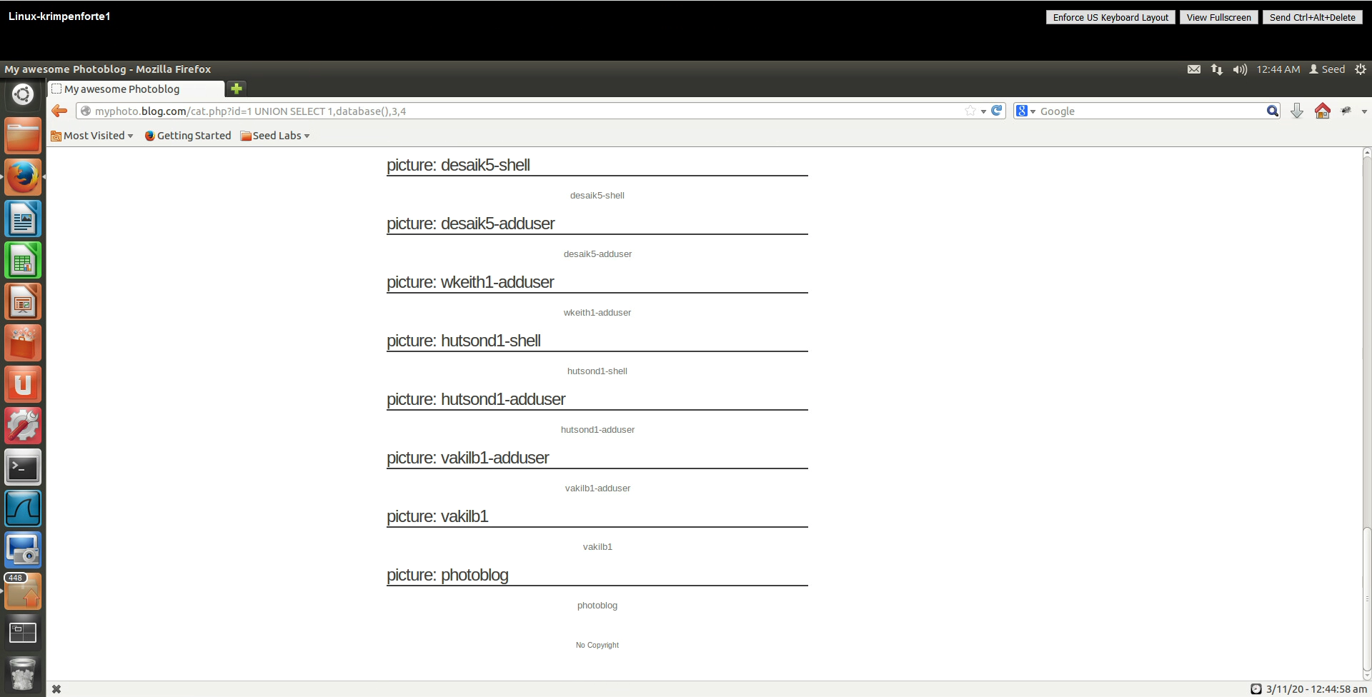



**Figure 3: putting in the function “database()”**

### Display all of the information together

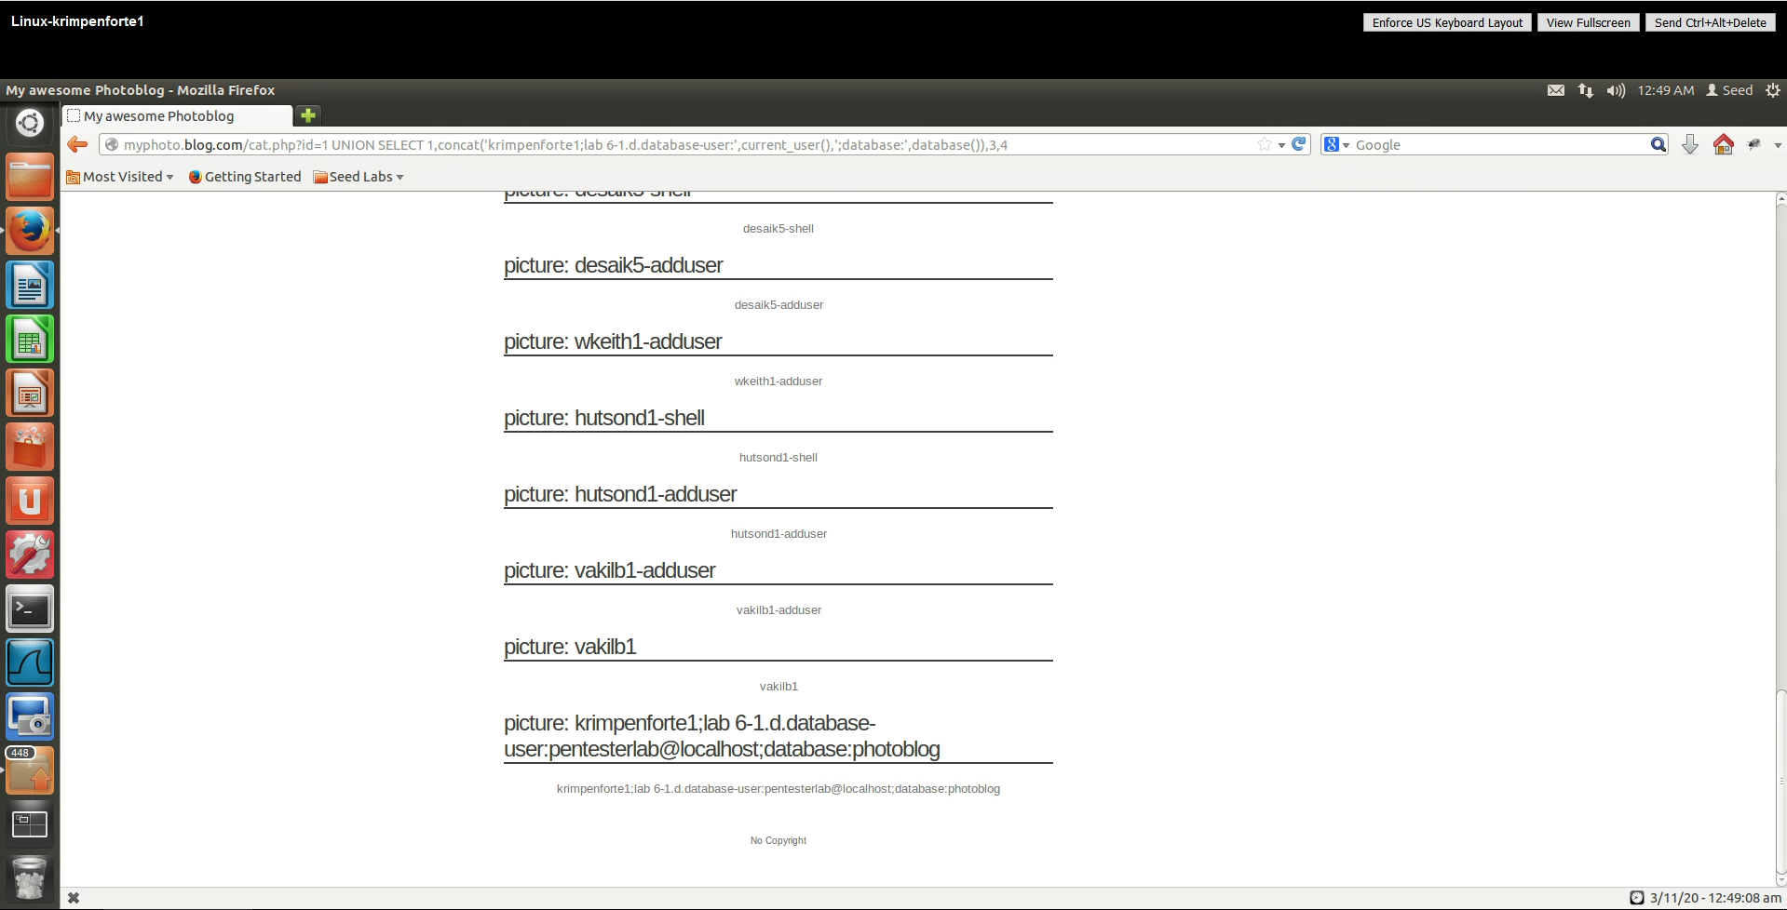



**Figure 4: putting everything together using “concat()”**

## Task II: Retrieve the data from the database

### Display all tables with their columns

#### Injected query results

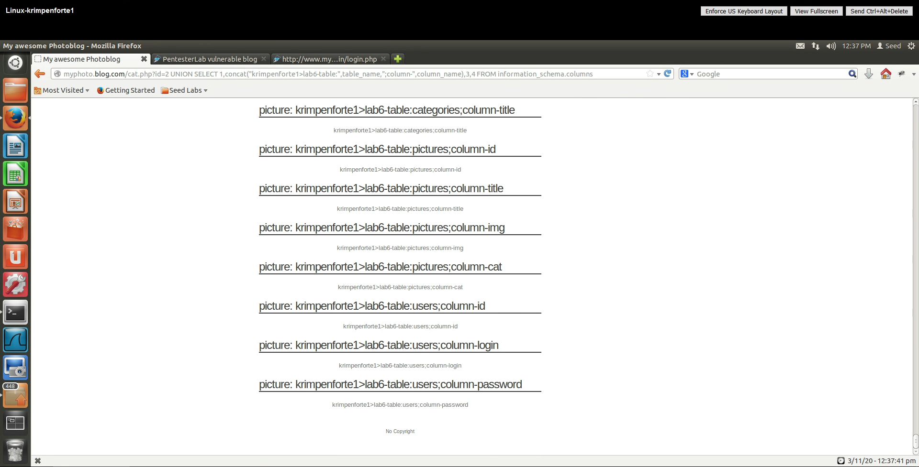

**Figure 5: All tables and all of their respective columns**

#### Table Name and its columns

From looking at Figure 5, the table name that holds the data we want is called *users* and the columns that are inside of *users* that we want are called *login* and *password*.

### Display contents of the table

#### Injected query results

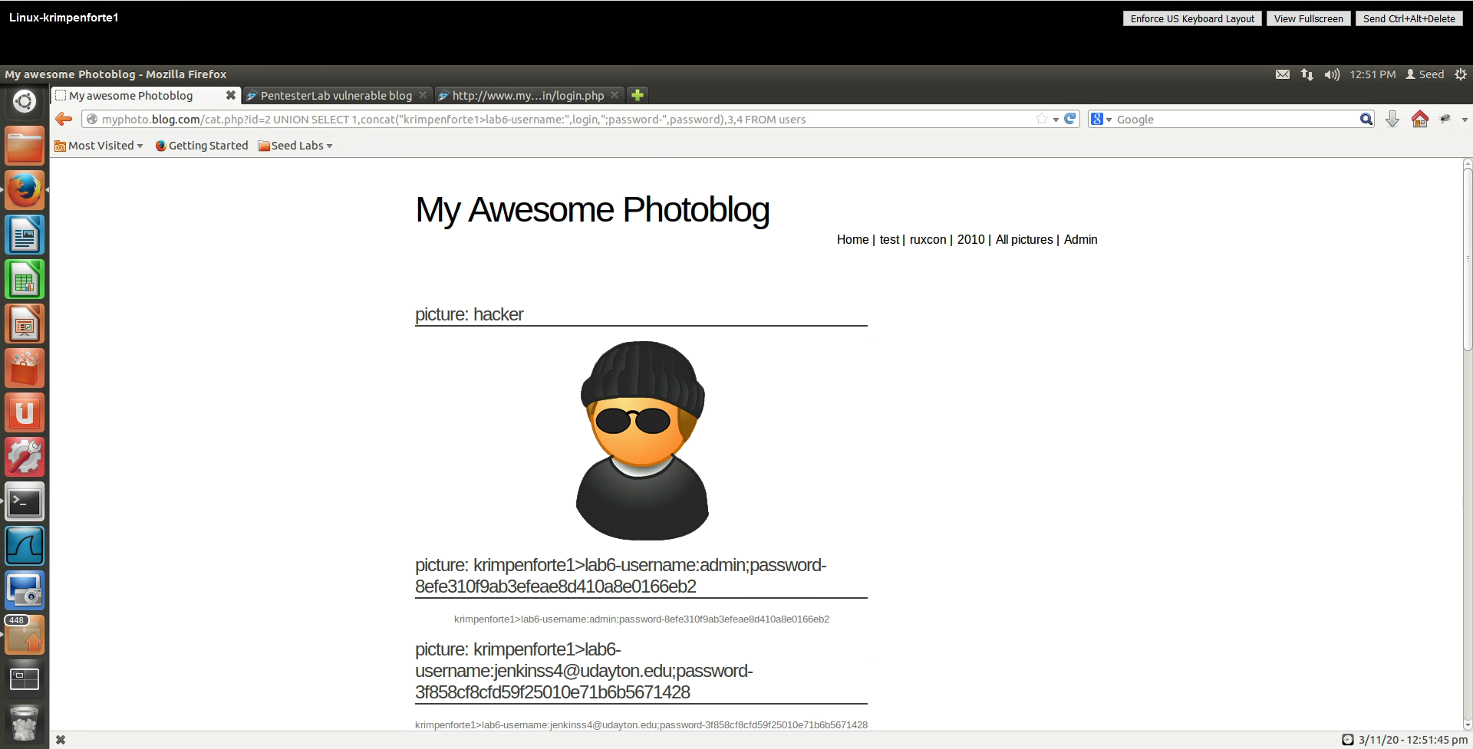



**Figure 6: retrieving the admin username and password**

#### Username and Password

#### 

**Figure 7: admin and its password**

### Log into the system with the made discovery

#### Demonstration

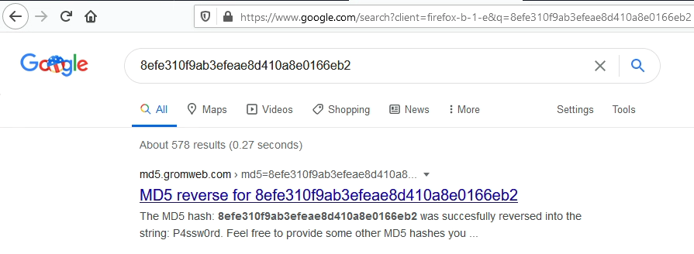

**Figure 8: Looking up the password**

To find the plaintext value, I searched the hash code up in Google and a website says the string is “P4ssw0rd.”

#### Results

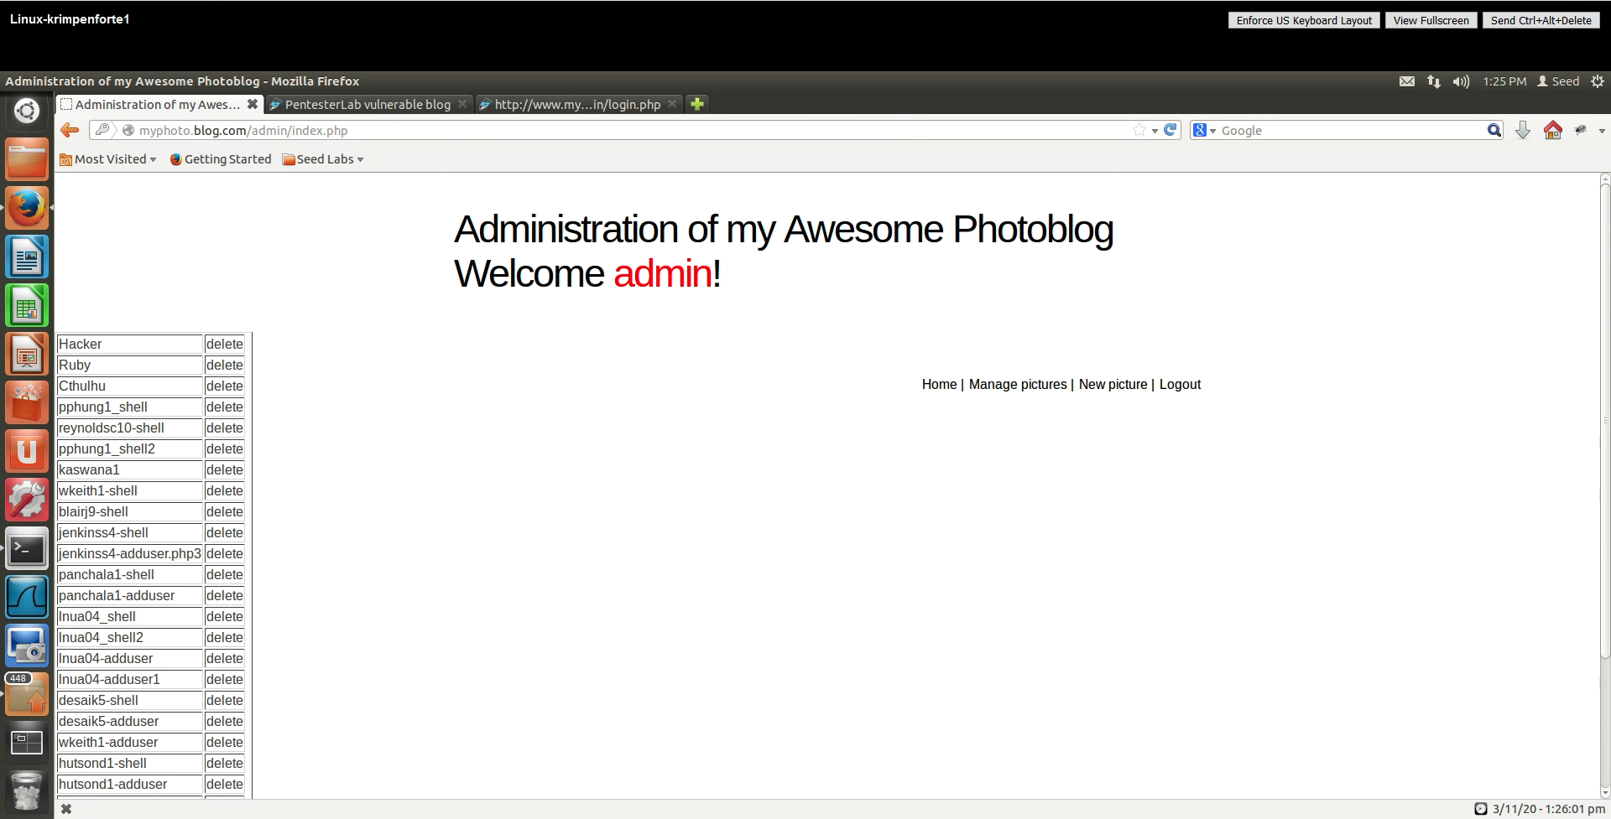

**Figure 9: Logged into admin using the username “admin” and password “P4ssw0rd”**

# Part II: Access to the web application and modify the system

## Task III: Upload a php application to execute commands

### Uploading a new file

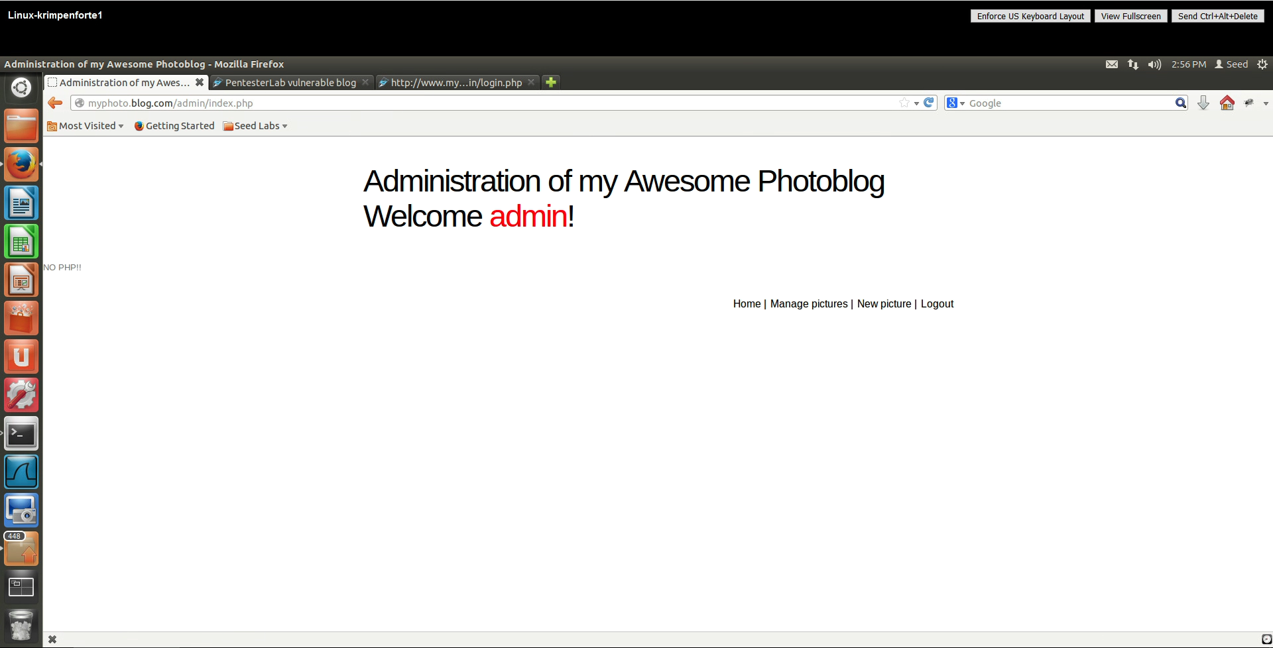

**Figure 10: When trying to add the php file, there was an error**

This error is caused above because the website had some sort of input validation. It checked to see if the code was a php file extension and it was.

### Try again…

#### Demonstration

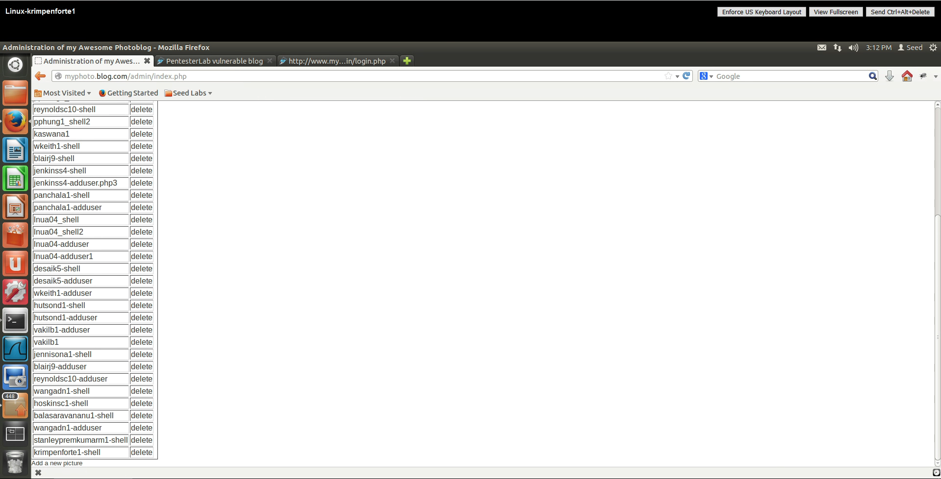



**Figure 11: successfully added a php file with the extension php3**

#### Interaction

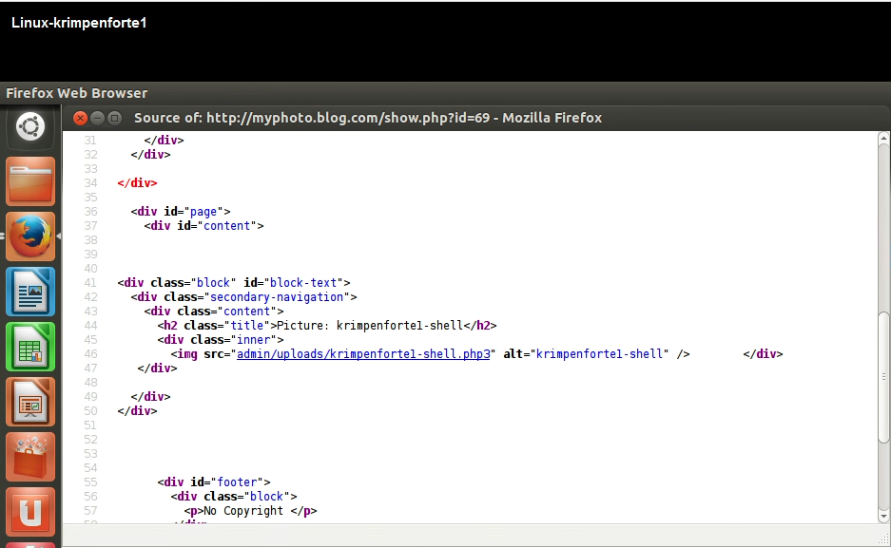

**Figure 12: Where the code is**

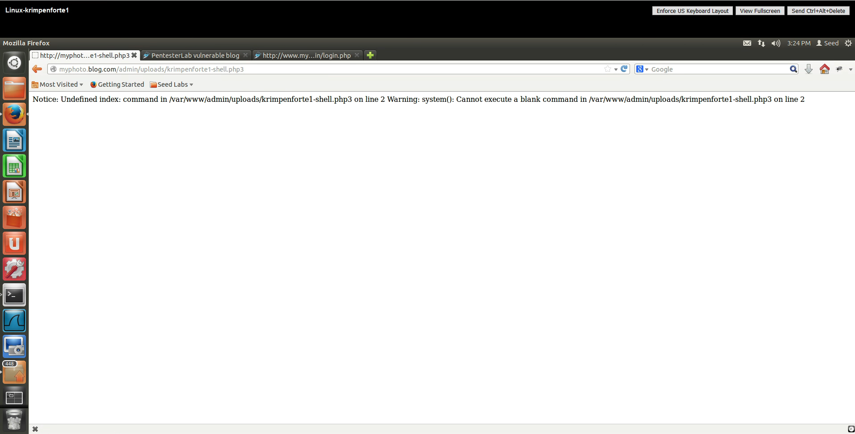

**Figure 13: when ran straight, there is an issue because “command” isn’t used**

There is an issue here because the placeholder called “command” isn’t instantiated with a command to process in *$_GET*. Therefore, in the next step, we will use command in the URL.

#### Execution

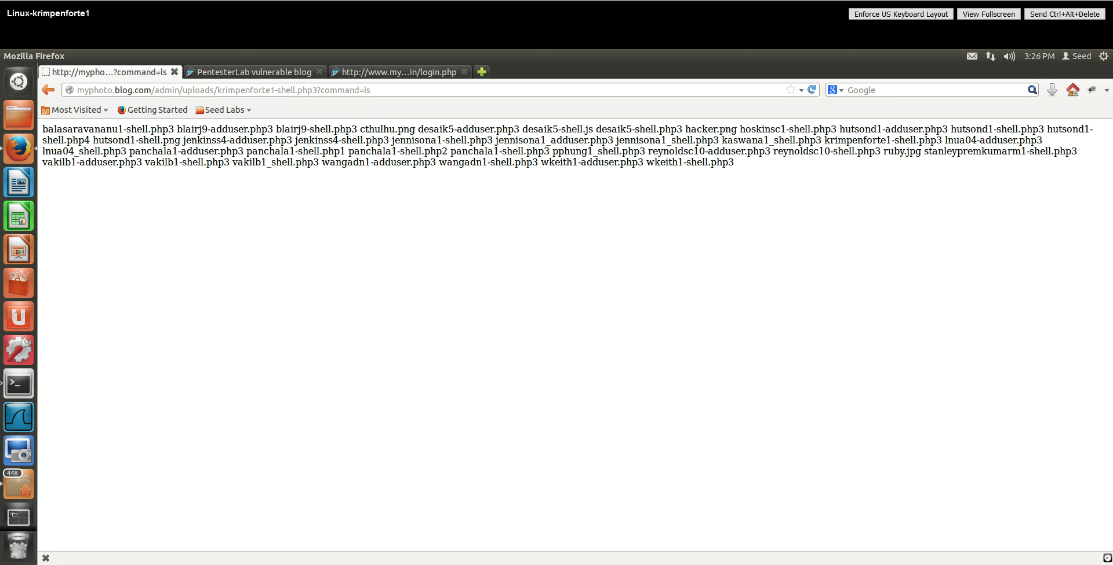

**Figure 14: ?command=ls**

The command entered was ls and now the code works.

## Task IV: Execute System commands to exploit the system further

### Repeat with new functions

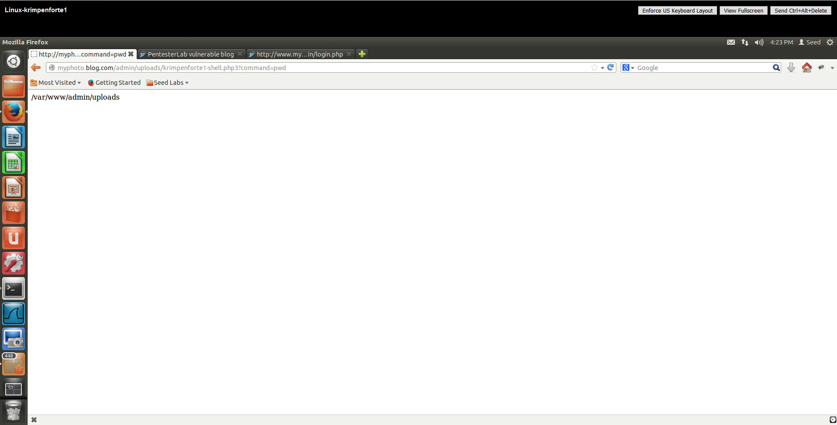

**Figure 15: ?command=pwd**

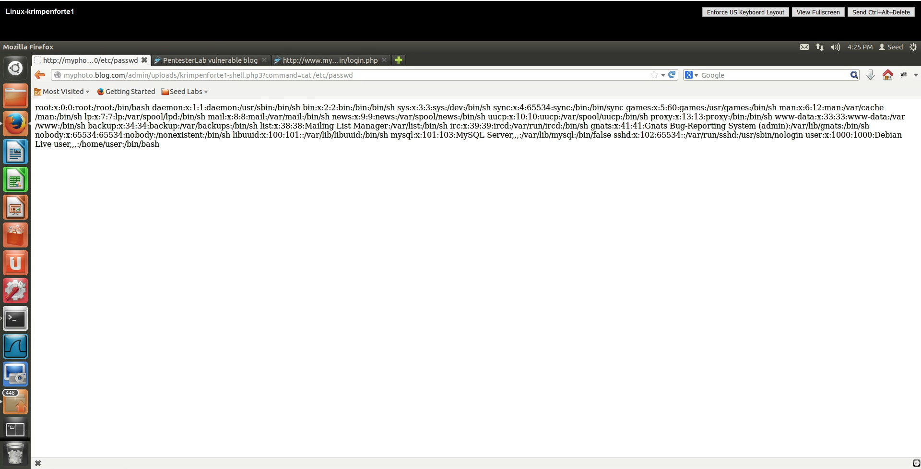

**Figure 16: ?command=cat /etc/passwd**

Because we can see /etc/passwd, we have root access with the admin login.

### Similar tests

#### List all files and folders

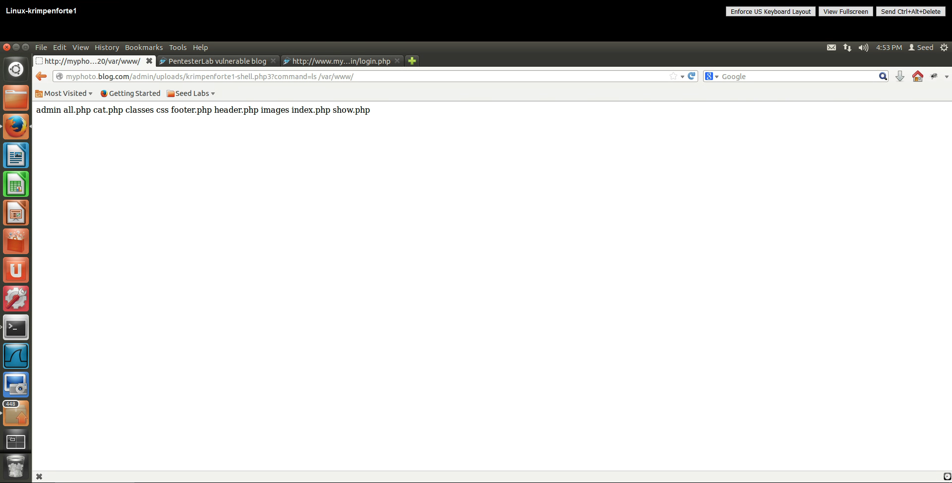

**Figure 17: ?command=ls /var/www/**

The shell call of “pwd” said that the root directory is /var/www/.

#### View cat /var/www/classes/db.php

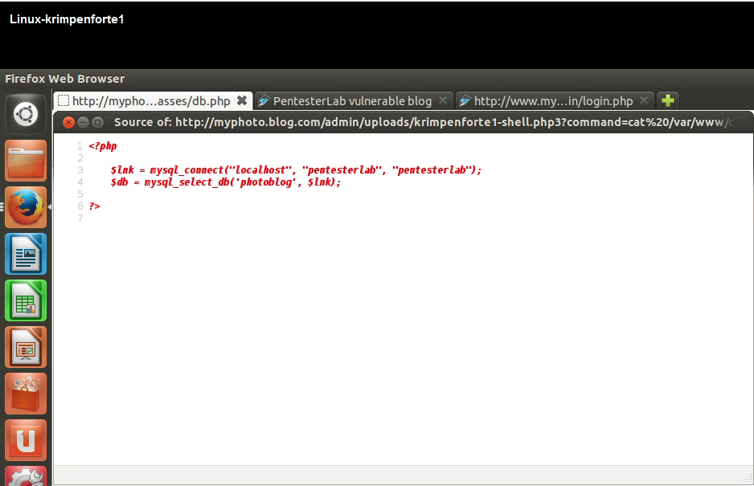



**Figure 18: Looking at the source code of the db.php file**

#### Figure out the credentials

As seen in Figure 18, the username and password seen in this file is “pentesterlab.”

## Task V: Insert new data into the database

### Content with the filename

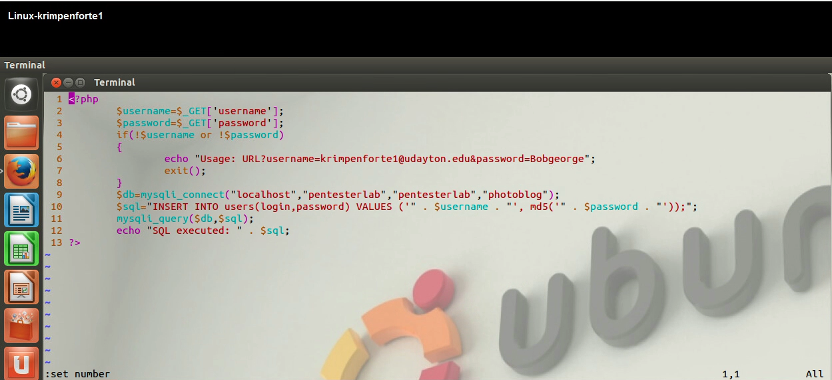

**Figure 19: Code for krimpenforte1-adduser.php3**

### Upload

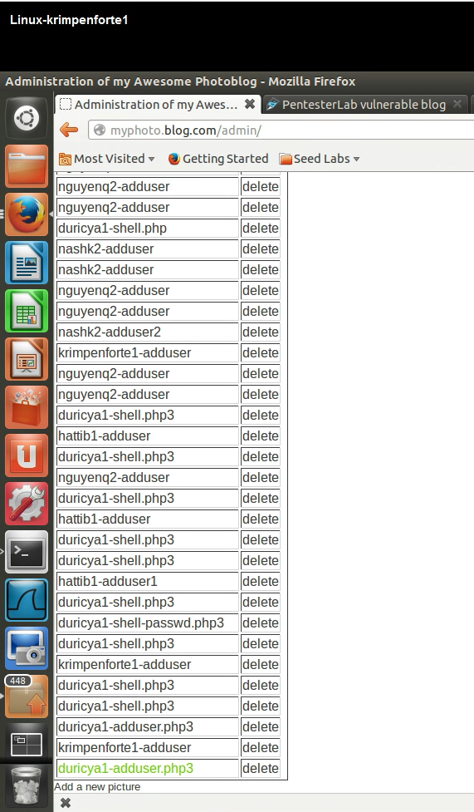



**Figure 20: Added my code as a picture for the adduser**

Was able to get another PHP file in because of the php3 extension.

### Provide Username and Password

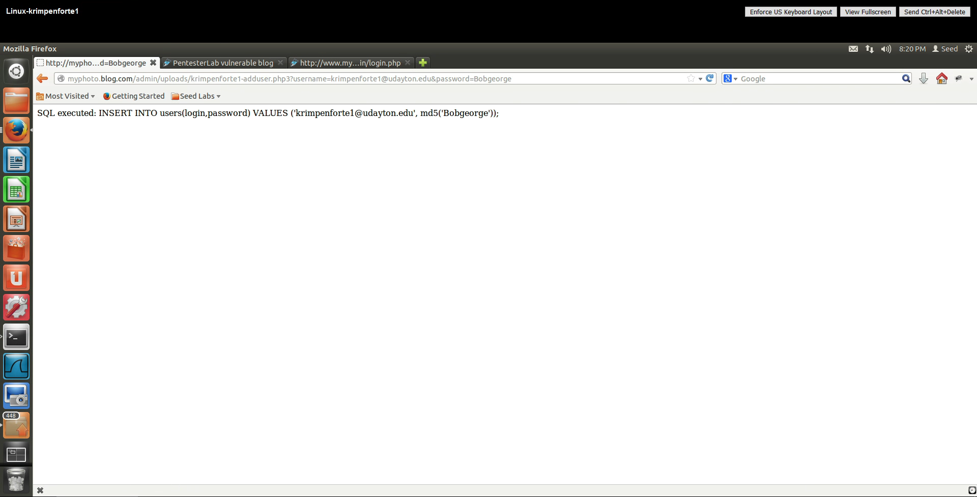

**Figure 21: Success addition of an added user (me)**

### Log in with new username and password

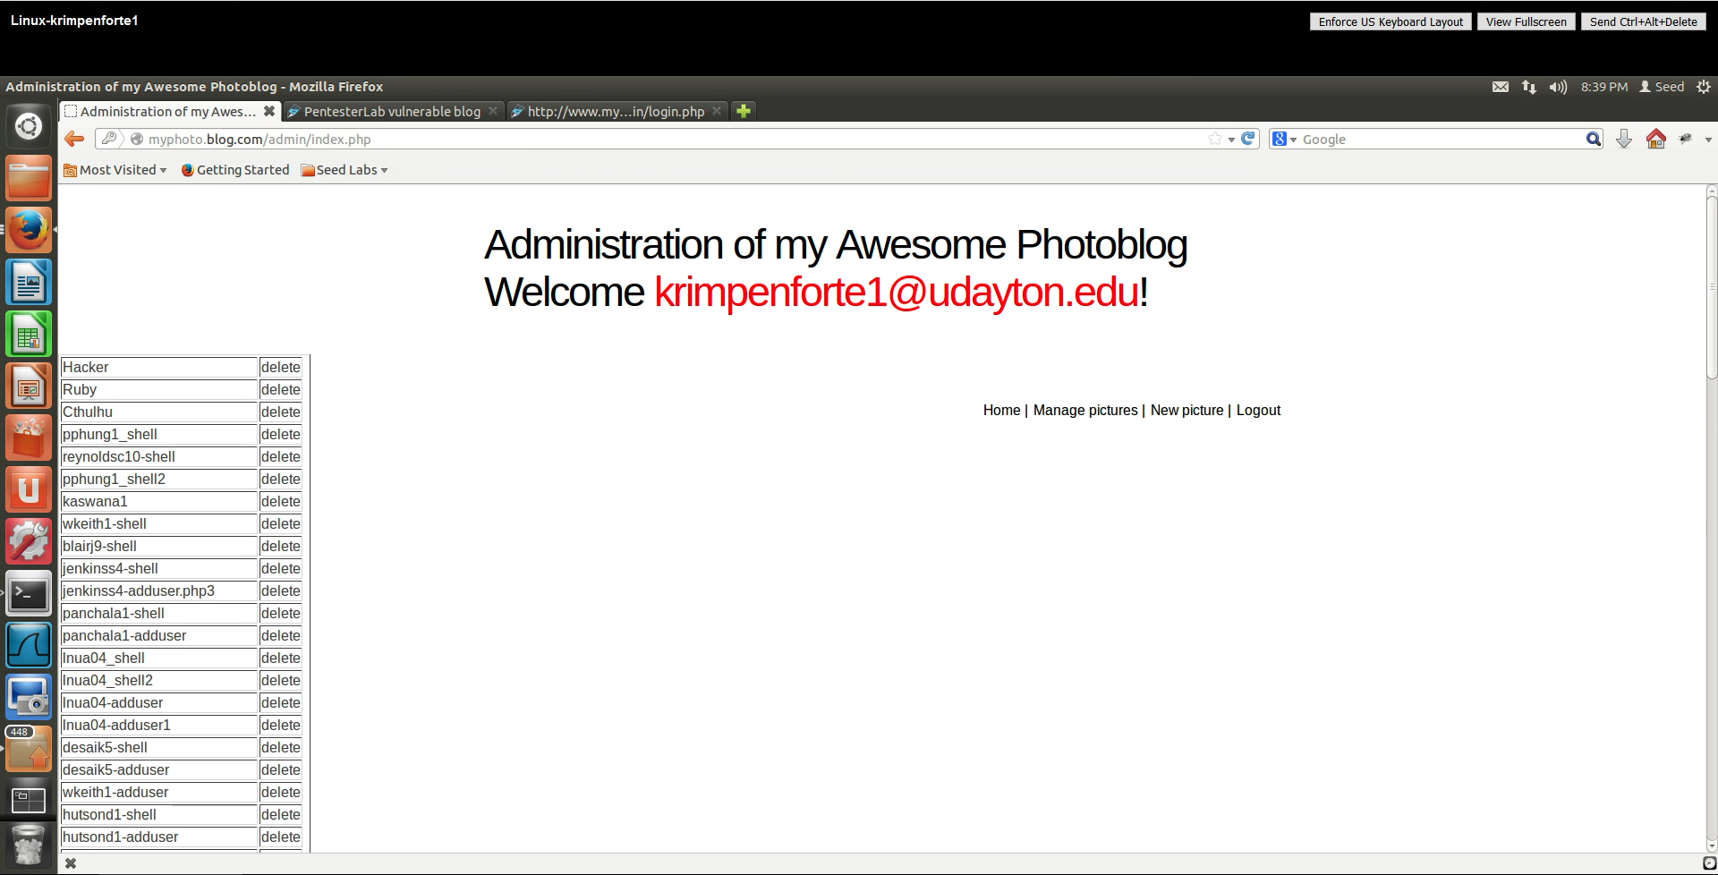

**Figure 22: Successfully logged into the admin using my added username**